|  |  |
| --- | --- |
| **Ex no : 8** | **Perform ETL Process and Develop a Dashboard** |
| **Date :** |

**AIM**

To perform ETL process and develop a dashboard for a selected health care data source.

**PROCEDURE**

Step 1: Perform all the ETL process by inspecting each and every attributes.

Step 2: Create the charts that are needed by choosing attributes in a separate sheet.

Step 3: Connect to the tableau server using your tableau login if needed

Step 4: Choose the background image (png format) for dashboard with separate panes

Step 5: Import the image into tableau and drag the workout tableau sheets into the panes of the imported image.

**OUTPUT**

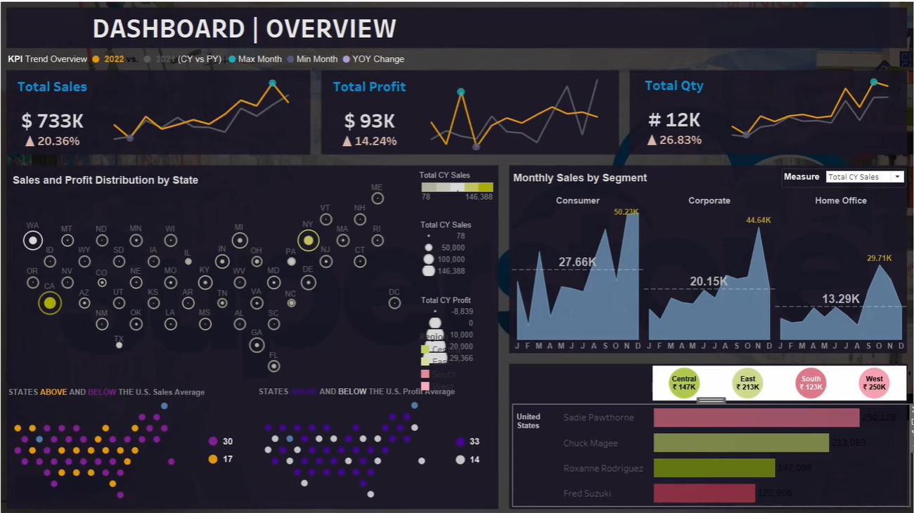

**RESULT**

Thus ETL process and development of a dashboard for a selected health care data source has been completed successfully.